**Review Sheet #2**

MTH 125

Fall 2018

1. Write C++ statements to carry out the following flow chart.

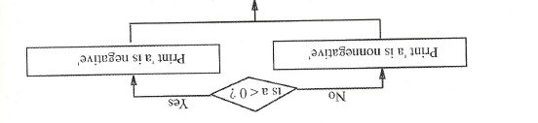

1. If $a=1.0$ and $b=3.0$. what are the values of $a$ and $b$ after the following statements are executed?

$\text{if}\left(a>b\right)$

$a=2.0∗a;$

$\text{else }$

$b=2.0∗b;$

$\text{if}\left(a≥1.0\right)b=1.;$

1. Add to the area of a circle program (#4 on Review Sheet 1) the necessary statements to test if the radius is negative. If so, print a suitable message and bypass the computation of the area.
2. Are the following logical expressions true or false when i=0 and a=10.5?

(∧- logical AND, v – logical OR, ! - negation)

* 1. i<=0 v a>12.0
  2. !(i==0)
  3. i==0 ∧ a>10.0 v a<9.0

1. Give the result of the following nested if statement for the cases

$i=−3,i=0,i=21,\text{or}i=7.$

if(i==7)

{

cout<<"Res 1";

}

else if(i==0)

{

cout<<"Res 2";

}

else if(i==21)

{

cout<<"Res 3";

}

else

{

cout<<"Res 4";

}